Mathematics Methods Unit 3 & 4 Investigation 1 2022
Take Home Section

Student name: ________________ Teacher name: ________________

Task type: Investigation
Take Home out: Monday Week 4, Term 1, 2022
In class Validation: in usual maths rooms 7:40am
Time allowed for in class task: ____40_______ mins

Materials required: Formula Sheet; Calculators and/or Classpads

Standard items: Pens (blue/black preferred), pencils (including coloured), sharpener, correction fluid/tape, eraser, ruler, highlighters

Special items: Drawing instruments, NO NOTES
Task weighting: _10___% in class only

Formula sheet provided: Yes

Note: All part questions worth more than 2 marks require working to obtain full marks.

Question 1
Use Calculus, investigate the dimension of the largest rectangle that can be inscribed in a circle.
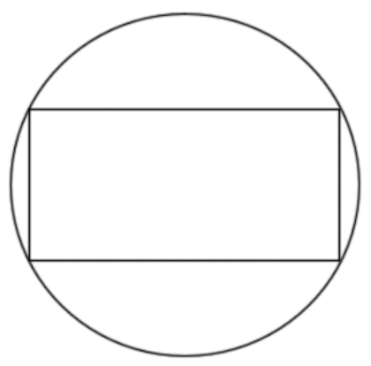
$$r$$
- Determine the largest area of the rectangle can be inscribed in a circle of radius $10 cm$. Justify your answer.

- Hence, determine the dimension and the largest area of the rectangle can be inscribed in a circle of radius $r cm$.

Question 2
A window frame is to be built from with a rectangular bottom and a semi-circle top. Given 20 meters of framing materials, determine the dimension of the window to allow the maximum amount of light to be let in.
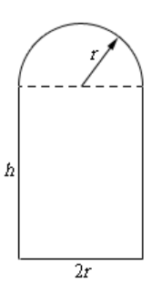

2D3D? wtf
End of Take-Home Section

